TRESTLE MASK SETS ORDER FORM
To order, please complete this form and either complete the credit card details below or send this form with a cheque made payable to Trestle Theatre Company Ltd to: Trestle Arts Base, Russet Drive, St Albans, Herts, AL4 0JQ. Tel: 01727 850950.
Orders can only be dispatched once payment has been received. As all masks are handmade & painted, we do our best to deliver within 2 weeks of payment, though this may increase at busy times. Prices shown are for mainland UK excluding VAT, each UK order is subject to a carriage fee of £10.
For Non-UK orders postage will have to be calculated, please contact us for exact prices.
If you need a pro forma invoice tick here:

MASKS | Price | Qty | Mask Numbers |  |  |  |  |  |  |  | Total £
Basic Mask Set  Light / Mid / Dark tone (delete applicable) | £150 + vat |  | N/A |  |  |  |  |  |  |  | £
Intermediate Mask Set  Light / Mid / Dark tone (delete applicable) | £145 + vat |  | N/A |  |  |  |  |  |  |  | £
Half Mask Set  Light / Mid / Dark tone (delete applicable) | £245 + vat |  | N/A |  |  |  |  |  |  |  | £
Advanced Mask Set | £215 + vat |  |  |  |  |  |  |  |  |  | £
Advanced Mask Collection | £430 + vat |  | N/A |  |  |  |  |  |  |  | £
 |  |  | Please enter in the boxes above which of the 18 advanced masks you require (a set is 8 masks) see overleaf for full mask set
Individual Advanced Masks | £28 each + vat |  |  |  |  |  |  |  |  |  | £
Individual Half Masks | £32 each + vat |  |  |  |  |  |  |  |  |  | £
Individual Basic/Intermediate Masks | £20 each + vat |  |  |  |  |  |  |  |  |  | £
TOTAL before VAT  Please add £10, if delivery is within mainland UK  Please add VAT at the current rate VAT  TOTAL AMOUNT PAYABLE |  |  |  |  |  |  |  |  |  |  | £  £  £  £

Please select 8 Advanced Masks from the selection below.
Please note that due to the hand painted nature of these masks, actual colours may vary.

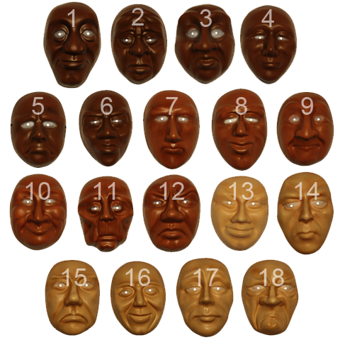

ENTER YOUR CONTACT DETAILS HERE:
Contact: |  | Company:
Address: |  | Postcode/  zip code:
Country: |  | Telephone:
Email:

PAYMENT OPTIONS
Thank you for downloading Trestle’s Mask order form. If you would prefer to order and pay for your masks online please visit www.trestle.org.uk/mask-shop
BACS/BANK TRANSFER: If you wish to pay via BACS/Bank Transfer, use the following bank details, please email masks@trestle.org.uk when you have made the payment:
Bank : Barclays Bank PLC
Whetstone and Finchley Group
1250 High Road
Whetstone
London N20 0PB
Sort code: 20-95-61
Account No: 00128627
Account Name: Trestle Theatre Company Ltd
IBAN No: GB15 BARC 2095 6100 1286 27
- CREDIT CARD PAYMENTS: You can pay with a credit/debit card. Please call us with your card details on +44(0)1727 850950

Please email masks@trestle.org.uk if you would like to discuss your order in more detail or to request International Postage costs.

Would you like to join our mailing list?  yes  no
Which areas of Trestle’s work are you interested in? (Tick one or more)
 Trestle Touring (Trestle’s national and international touring theatre productions)
 Trestle Arts Base (What is On at Trestle’s theatre venue and arts centre in Hertfordshire)
 Trestle Taking Part (Workshops for schools, participatory projects, professional training)

From time to time, we may wish to send your information about other companies that we think will be of interest to you. Please tick the box if you are happy to receive such information:

Facebook: @TrestleTheatre Instagram: @TrestleTheatre Twitter: @Trestle_Masks
#MasksInAction


